HSE Drill Details
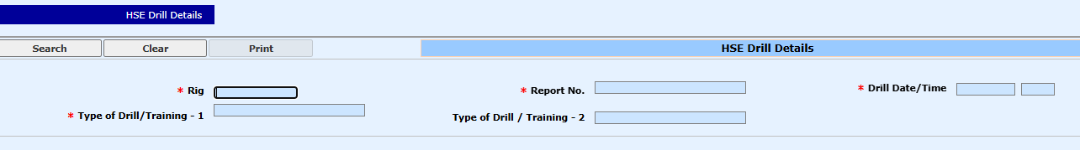

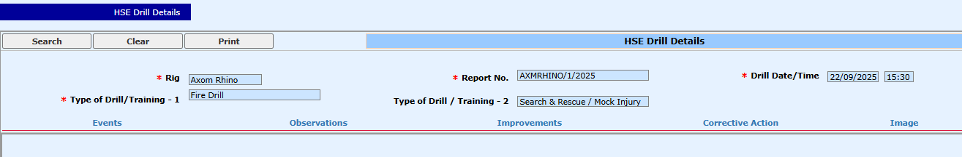

select *From eos_HSE_Drill_Record_Event

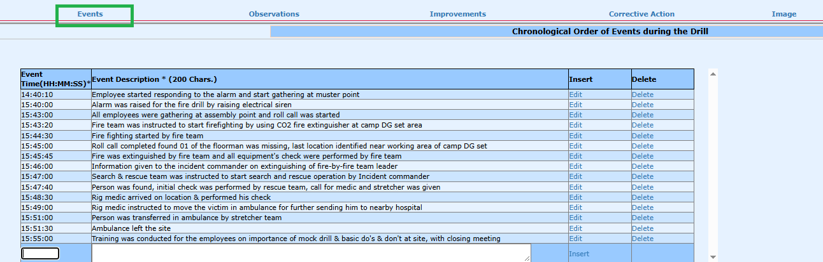

select *From eos_HSE_Drill_Record_Observation

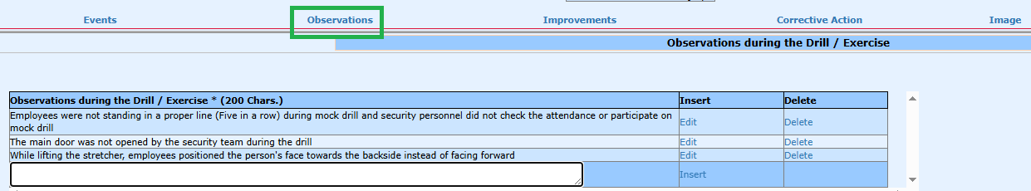

select *From eos_HSE_Drill_Record_Improvement
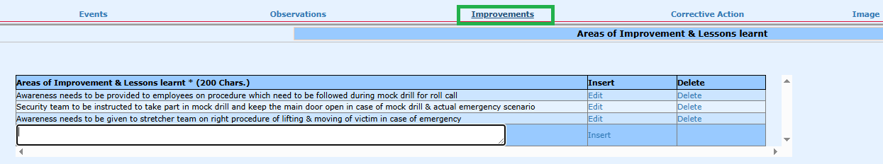

select *From eos_HSE_Drill_Record_Corrective_Action

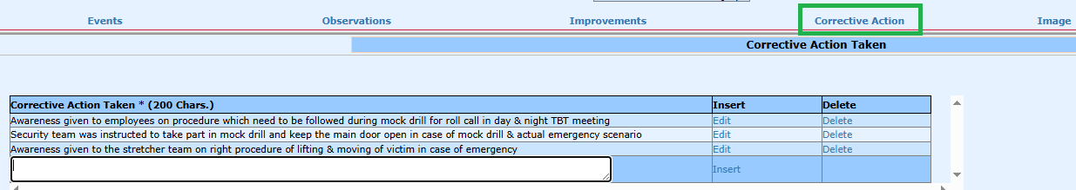

select *From eos_HSE_Drill_Record_Photo_Upload
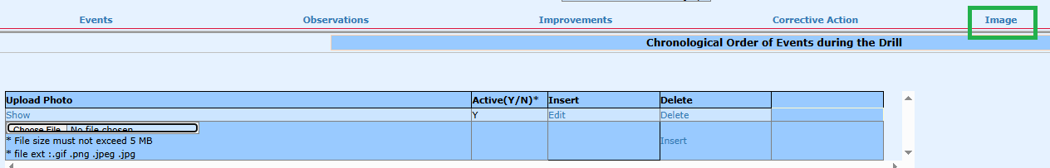
Pls store images @ path: /Images/HSE_Drills_Photos/1.jpg

On click of SHOW : display the respective uploaded image

Print: PDF file format is attached with Email

